Q1 | Create a table called Orders with columns: order_id, user_name, total_amount, and order_date. Insert 5 sample rows with different users and order amounts, including at least one NULL value for total_amount.
Code | Create table orders:-  CREATE TABLE Orders ( order_id INT AUTO_INCREMENT, user_name VARCHAR(50), total_amount DECIMAL(10,2), order_date DATE, PRIMARY KEY(order_id) );  Insert records:  INSERT INTO Orders (user_name, total_amount, order_date) VALUES ('Mayank', 1200.50, '2026-07-01'), ('Rahul', 850.00, '2026-07-02'), ('Priya', NULL, '2026-07-03'), ('Mayank', 450.75, '2026-07-04'), ('Sneha', 2200.00, '2026-07-05');
Output | 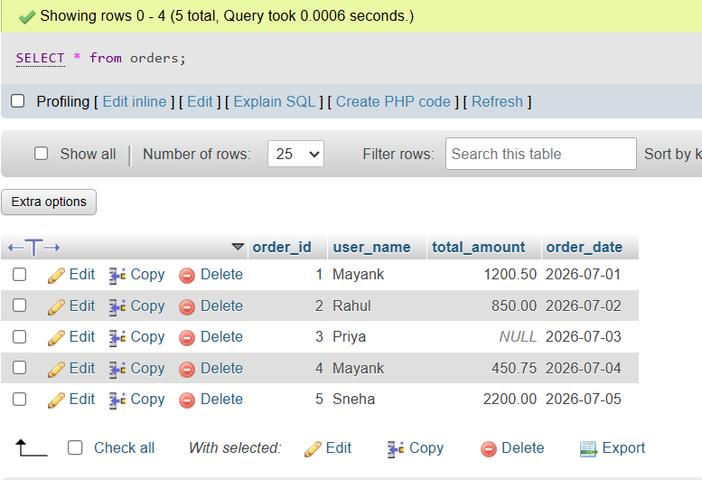

Q2 | Write a SQL query to count how many orders were placed by each user in the Orders table, displaying user_name and the number of orders as order_count.
Code | SELECT user_name, COUNT(order_id) AS order_count FROM Orders GROUP BY user_name;
Output | 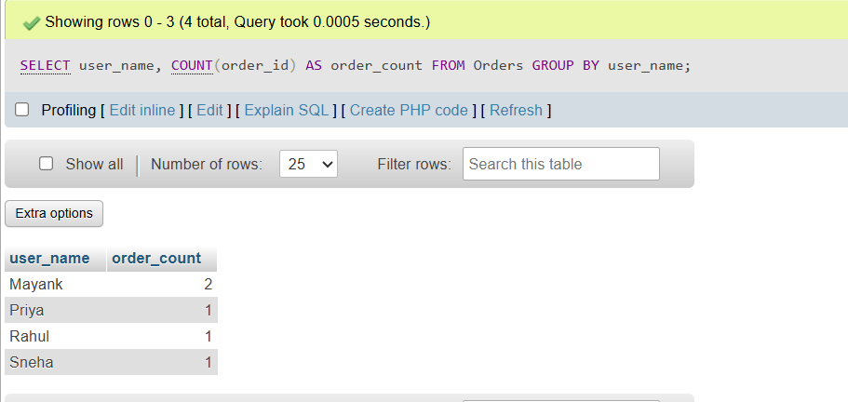

Q3 | Write a SQL query to calculate the average total_amount of all orders in the Orders table, making sure to ignore any NULL values.
Code | SELECT AVG(total_amount) AS average_order_amount FROM Orders;
Output | 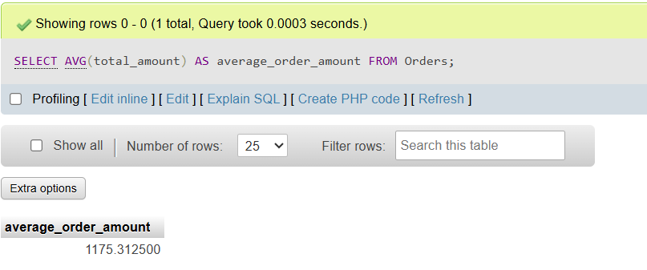

Q4 | Suppose you are building a Flipkart-style dashboard: Write a SQL query to find the highest and lowest order amounts (MAX and MIN) from the Orders table, and display both values in a single result row.
Code | SELECT MAX(total_amount) AS highest_order_amount, MIN(total_amount) AS lowest_order_amount FROM Orders;
Output | 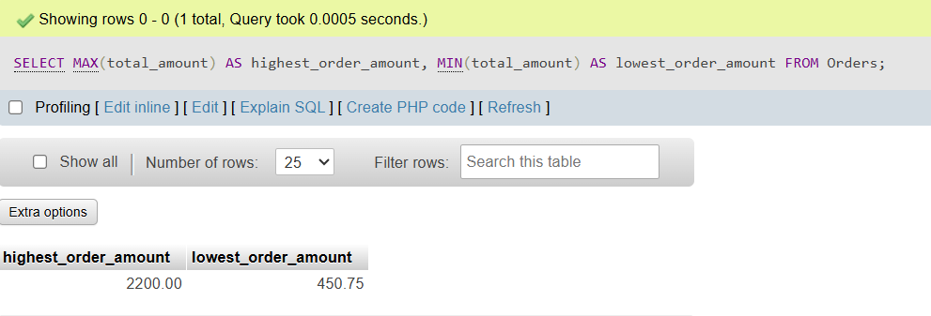

Q5 | Write a SQL query to calculate the total sales (SUM of total_amount) for all orders, but only include orders where total_amount is not NULL.<br><br><em><strong>Hint:</strong> Use a WHERE clause to filter out NULL values before applying the SUM function.</em>
Code | SELECT SUM(total_amount) AS total_sales FROM Orders WHERE total_amount IS NOT NULL;
Output | 